**Big Mountain Resort – Investigation into Increasing Revenue by Adjusting Ticket Prices**

*Lee Stetson*

*Problem Statement -* As a leading ski resort, Big Mountain Resort (BMR), is expanding with the installation of a new chairlift. Despite the improvement to the resort’s facilities, it raises questions about the resort’s profits. The new chairlift will add an additional $1.54 million in operating costs. Additionally, it is evident that BMR’s ticket pricing strategy may not maximize potential revenue given the resort’s amenities relative to other resorts in this market. It has been proposed that a data-driven pricing strategy in conjunction with potential site improvements can increase revenue for BMR. A question must be answered -- How can Big Mountain Resort reduce operational costs and/or increase ticket price (revenue) so that profits increase by at least $3 million by the end of the year? Data about other ski resorts and their capabilities and pricing have been provided. It should be noted that an increase in ticket price will not guarantee increased revenue as consumers may not be willing to pay the new price. It may be difficult to predict the impact on costs due to the scope of the provided dataset. Additional data on operating costs may be necessary.

*Data Wrangling –* Initial data wrangling and cleaning provided insights on the structure of the data as well as any assumptions or restructuring that needed to be made. It was concluded that there was no duplicate data present and BMR’s data was present. Rows for resorts with missing price data or attributes that could not be inferred were removed from the working dataset. State data was scraped from the web and added to the dataset. Also, it was observed that the adult weekend price was equal to or greater than the weekday price with most cases being equal (especially at the current BMR price point). This resulted in the weekday price being dropped and the suggestion that ticket price stay consistent between weekdays and weekends. The plot below shows the prices for all resorts.

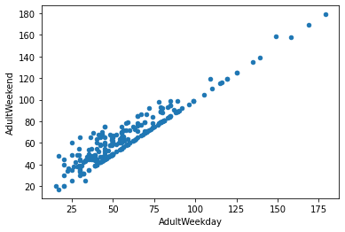

*Exploratory Data Analysis –* A deeper look into the data provided information about the relationship between features. After including the state data and scaling the features, early primary component analysis was conducted to determine some of the important features. It was concluded that resorts_per_100kcapita and resorts_per_100ksq_mile are relatively good predictors of price. It was also determined that state alone does not do well in predicting prices. The heatmap below shows the relative correlation of each feature to the target feature (AdultWeekend price). This additional insight assisted in the preprocessing and modeling stages of the study.

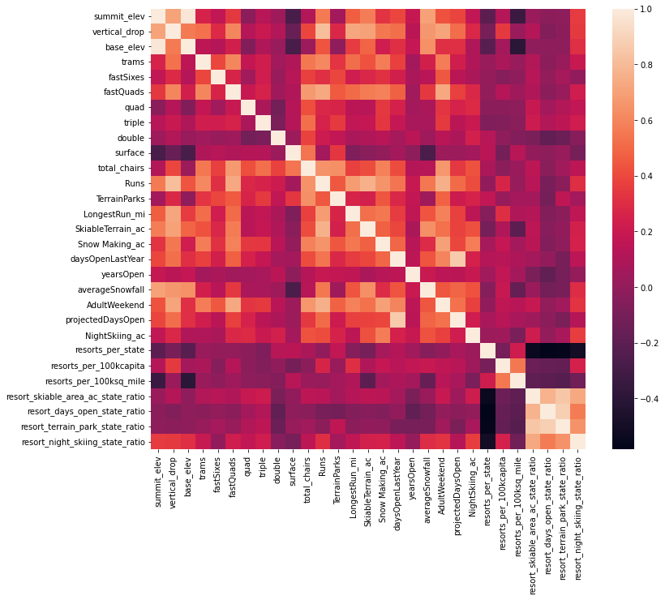

*Preprocessing & Model Development –* The dataset was split into training and test data and was ultimately split into 5 folds to cross validate the models across the entire dataset. Two methods of data imputing were tested. Missing data would either be filled with that feature’s mean or its median. Two models were considered when attempting to predict an appropriate price for BMR tickets. The first was a linear regression model and the second was a random forest model. In both cases, the missing data was imputed then the dataset was scaled and fitted to one of the models. Gridsearch cross validation compared the parameters used from the dataset as well as the method of imputing and scaling to determine the best model. The cv score based on R-squared error and the observation of mean absolute error showed that the random forest model using 69 estimators, imputing with the median, and no scaling was the best model. It had a cross-validation mean absolute error of $9.64 and an R-squared error of 0.7097. Finally, it was confirmed that a larger training set size would not improve the cross-validation score.

*Modeling & Conclusion –* The model was finally trained on the entire dataset excluding BMR. According to the model, the suggested ticket price based on the current facilities is **$95.87** with a mean absolute error of $10.39. This means that at a minimum, BMR can fairly charge $85.48 for an annual revenue increase of $7.84 million based on the projected 350,000 visitors with an average stay of 5 days. This estimate is based solely on the current site's amenities as compared to those at other resorts across the country. BMR’s price compared to other resorts is shown below to the left. On the right is BMR’s place in total runs compared to the rest of the resorts. This metric is the second most important predictor based on the random forest model and shows that BMR is in the upper percentile for this metric.

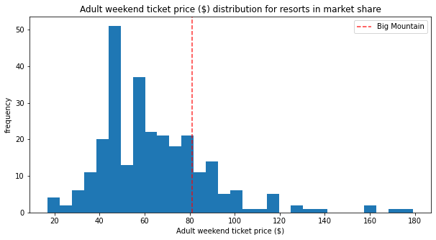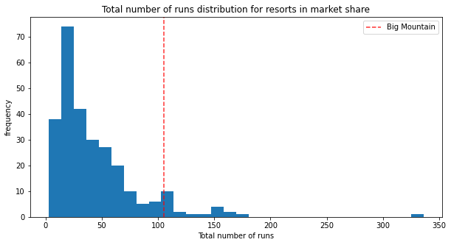

While the justified price increase will more than cover the increased operating costs of the new lift and meet the criteria of the problem statement, site changes may further improve revenue and profits. It was found that a future site improvement of adding a run, increasing the vertical drop by 150 feet, and installing an additional chair lift supports increasing the ticket price by an additional $1.99 for an annual revenue increase of $3,474,638. Closing one run should not have an impact on ticket price and closing 2 to 5 will lead to revenue losses of up to $1.26 million. Anything more than that will cause major losses.

*Further Work -* Despite the results of the modeling, testing would be required to validate that the model was a good predictor of the potential revenue gains from these changes. Additionally, more data could be obtained to improve the model and to investigate the cost implications of the site improvements described. This data could include the operating costs associated with additional runs, additional lifts, and longer runs. Data from customer surveys can be valuable in predicting which changes are more desirable for consumers. Since Big Mountain Resort already had relatively high prices (especially in Montana), a major ticket price increase ($14.87) might be hard to sell. The improvements can be rolled out slowly to observe their impact. This model can also be fed live data to keep up with industry trends. A more user-friendly model can be deployed so that business analysts or executives can make predictions about the effect of proposed changes.